James M. Griffith

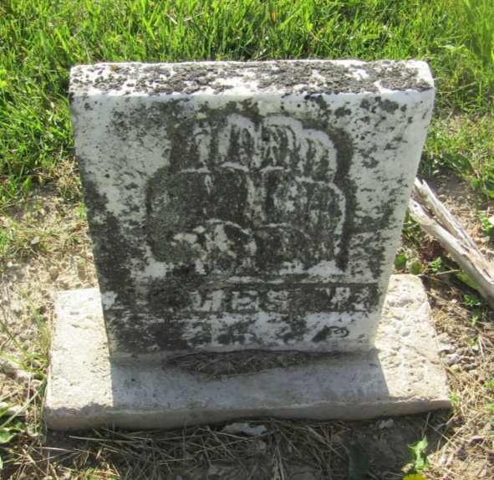

No further information found at this time

