Gertrude (Beavans) Griffith
January 11, 1892 – January 28, 1951

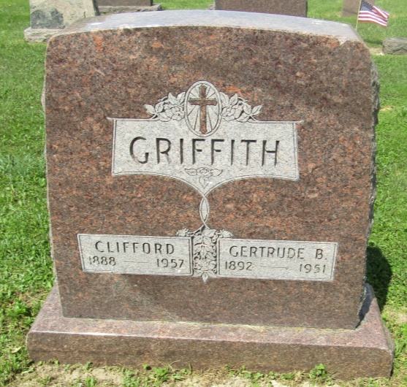

Gertrude Griffith
in the Indiana, U.S., Death Certificates, 1899-2011
Name: Gertrude Griffith
[Gertrude Beavans]
Gender: Female
Race: White
Age: 59
Marital status: Married
Birth Date: abt 1892
Birth Place: Wells Co
Death Date: 28 Jan 1951
Death Place: Hartford, Bartholomew, Indiana, USA
Father: David Beavans
Mother: Grace Cunningham
Informant: Clifford Griffith; Montpelier, Indiana
Burial: January 31, 1951; Asberry Chapel Cemetery; Warren, Indiana

