Charlott (Griffith) Griffith
September 10, 1827 – August 29, 1909

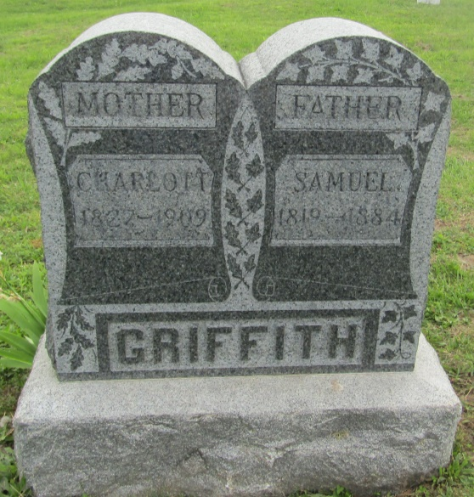

Charlett Griffith
in the Indiana, U.S., Death Certificates, 1899-2011
Name: Charlott Griffith
Gender: Female
Race: White
Age: 81
Marital status: Widowed
Birth Date: 10 Sep 1827
Birth Place: Indiana
Death Date: 29 Aug 1909
Death Place: Jackson, Wells, Indiana, USA
Father: John Griffith
Mother: Nancy Athens
Informant: Nancy ??
Burial: August 31, 1909; Asbury Chappel

