Simon Peter Gregory
June 7, 1830 – March 17, 1877

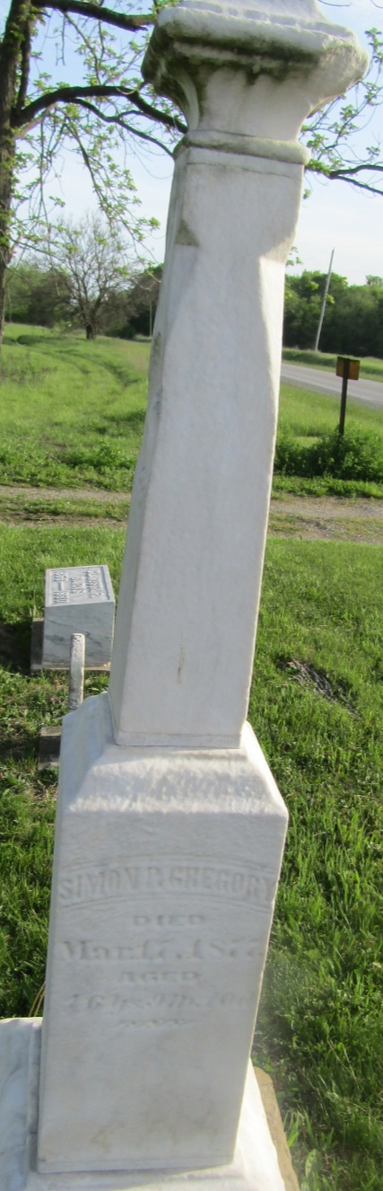

No further information found at this time

