Roger Lee Glessner
April 23, 1943 – July 15, 1944

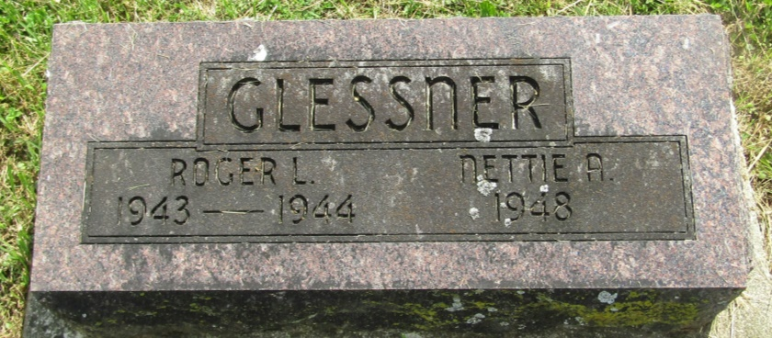

Roger Lee Glessner
in the Indiana, U.S., Death Certificates, 1899-2011
Name: Roger Lee Glessner
Gender: Male
Race: White
Age: 1
Marital status: Single
Birth Date: 23 Apr 1943
Birth Place: Wells Co
Death Date: 15 Jul 1944; struck by car
Death Place: Rural, Blackford, Indiana, USA
Father: Paul Glessner
Mother: Edna Fay Dawson
Informant: Paul Glessner; Montpelier, Indiana
Burial: July 18, 1944; Asbury Chapel; Wells County, Indiana

