Paul Glessner
March 13, 1904 – December 27, 1998

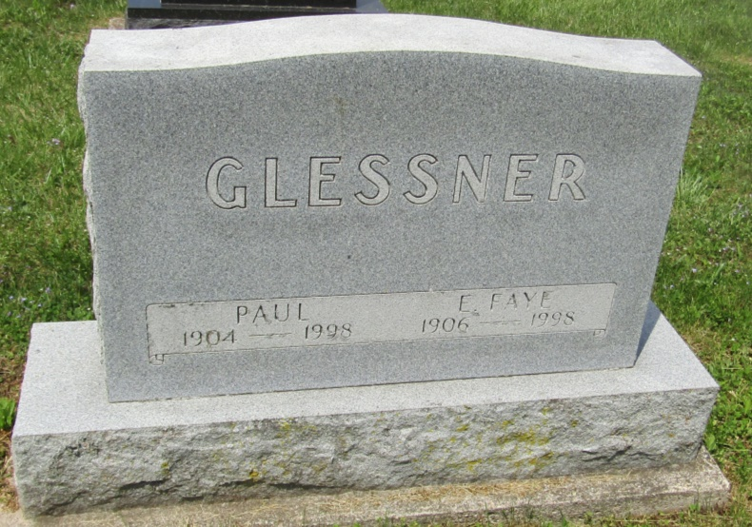

Paul Glessner
in the Indiana, U.S., Death Certificates, 1899-2011
Name: Paul Glessner
Gender: Male
Race: White
Age: 94
Marital status: Widowed
Birth Date: 13 Mar 1904
Birth Place: Grant County, IN
Death Date: 27 Dec 1998
Death Place: Montpelier, Blackford, Indiana, USA
Father: Charles Albert Glessner
Mother: Nora Spangler
Informant: Dwight Glessner; son; Montpelier, Indiana
Burial: December 31, 1998; Asbury Cemetery; Montpelier, Indiana

