Jackie Alan Glessner
July 30, 1933 – April 27, 1954

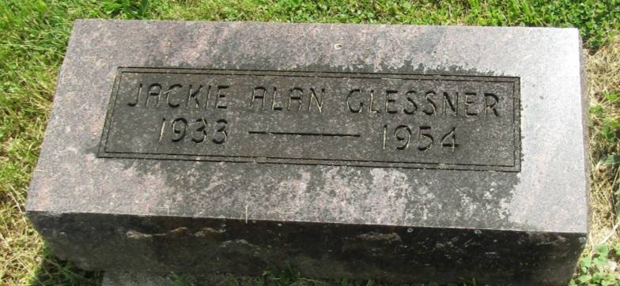

Jack Glessner, son of Mr. and Mrs. Paul and Fay Glessner, died Tuesday, April 27, 1954 victim of a car crash. Born July 30, 1933. Survived by parents; nine brothers and sisters; Billy, Ronald, Mrs. Peggy Meeks, Ralph, John, Jesse, Robert and Norma Mae. Asbury Cemetery.

Montpelier Herald Newspaper, Blackford County, Indiana
Thursday, April 29, 1954
*****

Indiana, U.S., Death Certificates, 1899-2011
Name: Jackie Alan Glessner
Gender: Male
Race: White
Age: 20
Marital status: Never Married (Single)
Birth Date: 30 Jul 1933
Birth Place: Wells Co Ind
Death Date: 27 Apr 1954
Death Place: Hartford, Blackford, Indiana, USA
Armed Forces: No
Father: Paul Glessner
Mother: Faye Dawson
Burial: April 29, 1954; Asbury Cemetery; Wells County, Indiana

