Edna Faye (Dawson) Glessner
April 15, 1906 – January 1, 1998

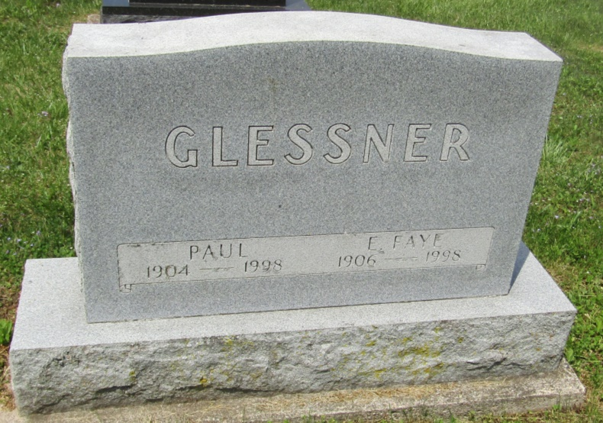

Edna Faye Glessner
in the Indiana, U.S., Death Certificates, 1899-2011
Name: Edna Faye Glessner
[Edna Faye Dawson]
Gender: Female
Race: White
Age: 91
Marital status: Married
Birth Date: 15 Apr 1906
Birth Place: Wells County, IN
Death Date: 1 Jan 1998
Death Place: Hartford City, Blackford, Indiana, USA
Father: Harrison McIntire Dawson
Mother: Corina Made Brown
Spouse: Paul Glessner
Informant: Paul Glessner; husband; Montpelier, Indiana
Burial: January 5, 1998; Asbury Cemetery; Wells County

