Emery D. Fuller
March 10, 1918 – December 25, 2005

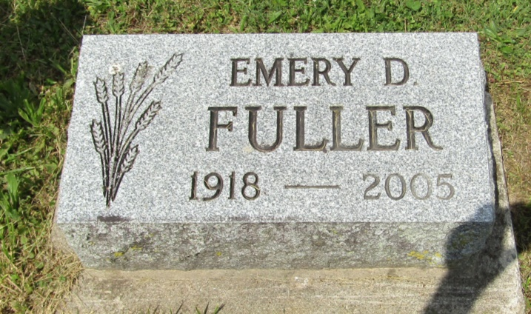

A Wells County farmer who retired in 1989, Emory D. Fuller, 87, of Chester Township died at 12:30 a.m. Sunday, Dec. 25, at his residence. He was a native of Wells County and attended Wells County schools. He was a member of the First Church of the Nazarene and the Wells County Farm Bureau.
Born March 10, 1918, in Wells County, he was a son of Henry Winfield and Mabel Marie Tucker Fuller.
Surviving are two brothers, Bill Fuller of Bluffton and Keith Fuller of Ossian; a sister, Geraldine Smith of West Palm Beach, Fla., and several nieces and nephews. He was preceded in death by a sister, Doris Jean Druckenmiller, and two brothers, Robert Fuller and Jack Fuller.
There will be no viewing and no services. Burial will be in Asbury Cemetery, Wells County. Glancy Funeral Homes, Walker Chapel, Montpelier, is in charge of arrangements.

Bluffton News-Banner, Wells County, Indiana
Tuesday, December 27, 2005

