Rosa Olive Fox
March 4, 1874 – October 4, 1875

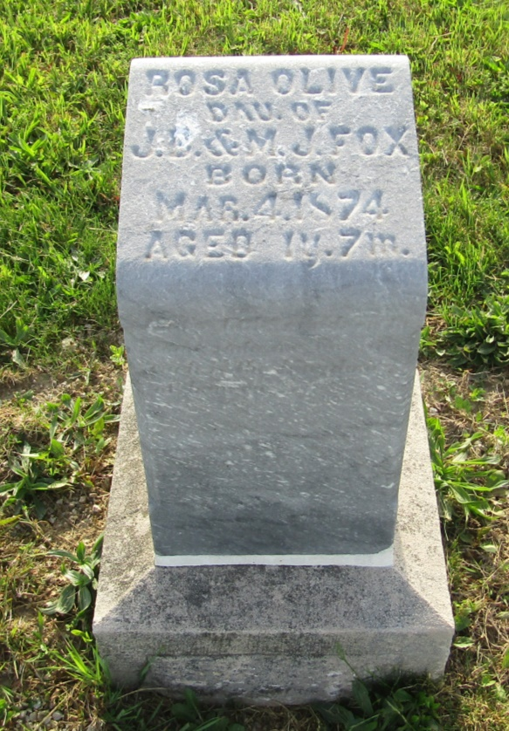

No further information found at this time

