James B. Fox
November 18, 1846 – February 28, 1876

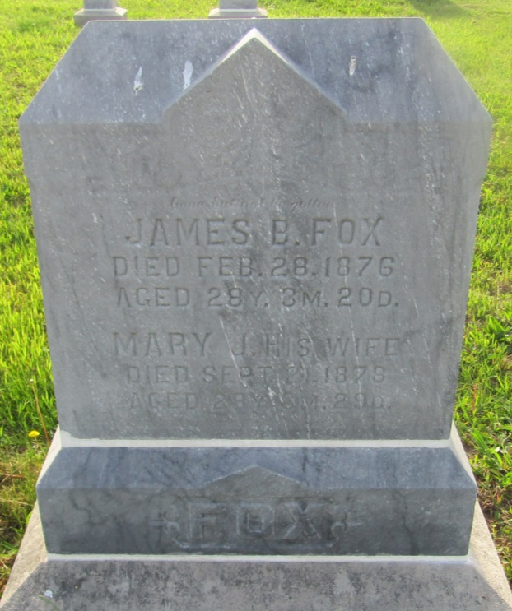

No further information found at this time

