Alonzo James Fox
November 10, 1875 – June 11, 1948

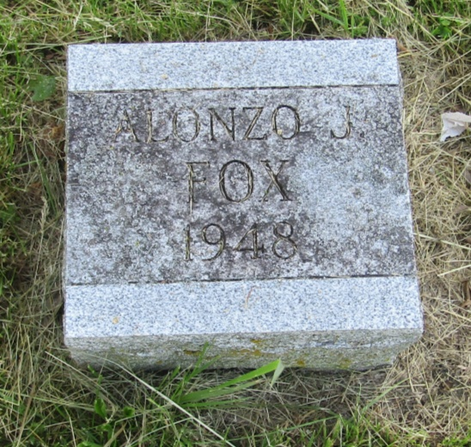

Alonzo James Fox
in the Indiana, U.S., Death Certificates, 1899-2011
Name: Alonzo James Fox
Gender: Male
Race: White
Age: 72
Marital status: Widowed
Birth Date: 10 Nov 1875
Birth Place: Indiana
Death Date: 11 Jun 1948
Death Place: Ray Twp Rural, Morgan, Indiana, USA
Father: James Fox
Mother: Mary Dennsen
Informant: Vera Kirk; Paragon R.R.
Burial: June 14, 1948; Asbury Cemetery; Wells County, Indiana

