Lydia (Smith) Falk
September 1, 1906 – May 29, 1992

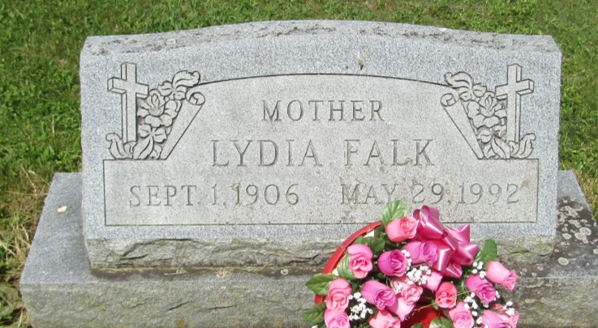

Lydia Falk
in the Indiana, U.S., Death Certificates, 1899-2011
Name: Lydia Falk
[Lydia Smith]
Gender: Female
Race: White
Age: 85
Marital status: Divorced
Birth Date: 1 Sep 1906
Birth Place: Adams County, Indiana
Death Date: 29 May 1992
Death Place: Hartford, Blackford, Indiana, USA
Father: William Smith
Mother: Elizabeth Koontz
Informant: Roger Falk; son; Hartford City, Indiana
Burial: June 1, 1992; Asbury Cemetery; Wells County, Indiana

