Mary Lettie Ely
July 1, 1891 – October 20, 1987

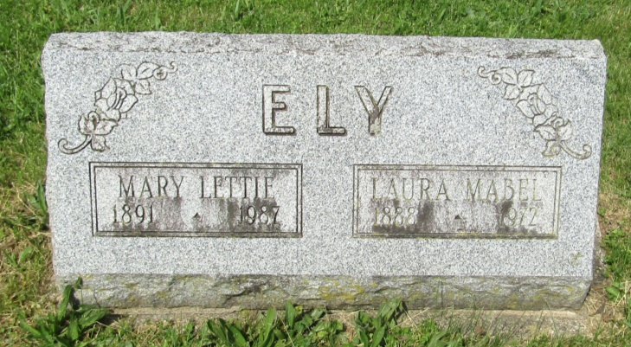

Mary Lettie Ely
in the Indiana, Death Certificates, 1899-2011
Name: Mary Lettie Ely
Gender: Female
Race: White
Age: 97
Marital status: Never Married (Single)
Birth Date: 1 Jul 1891
Birth Place: Indiana
Death Date: 20 Oct 1987
Death Place: Harford, Blackford, Indiana , USA
Father: Franklin Ely
Mother: Margaret Chandler
Informant: Lorian Byall; niece; Hartford City, Ind.
Burial: Oct. 24, 1987; Asbury Cem., Wells Co., Ind.

