Margaret J. Ely
May 1, 1853 – June 20, 1897

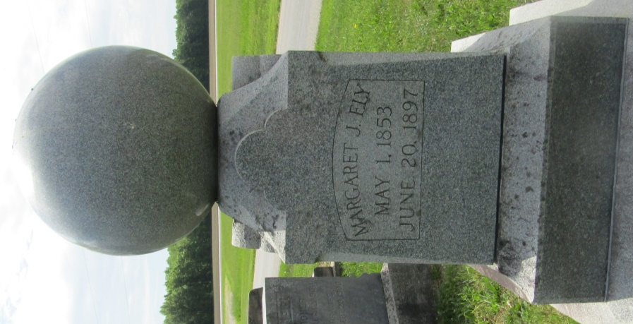

No further information found at this time

