Berenice May Elliott
January 14, 1913 – February 2, 2000

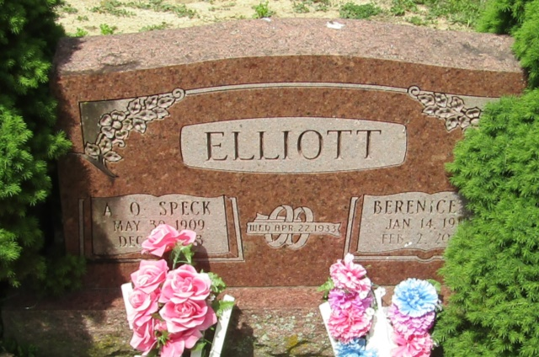

Berenice M. Elliott
in the U.S., Social Security Death Index, 1935-2014
Name: Berenice M. Elliott
Social Security Number: xxx
Birth Date: 14 Jan 1913
Issue Year: Before 1951
Issue State: Indiana
Last Residence: 49002, Portage, Kalamazoo, Michigan, USA
Death Date: 2 Feb 2000

