Sarah Jane (Wickersham) Kitterman-Dick
July 16, 1837 – June 26, 1912

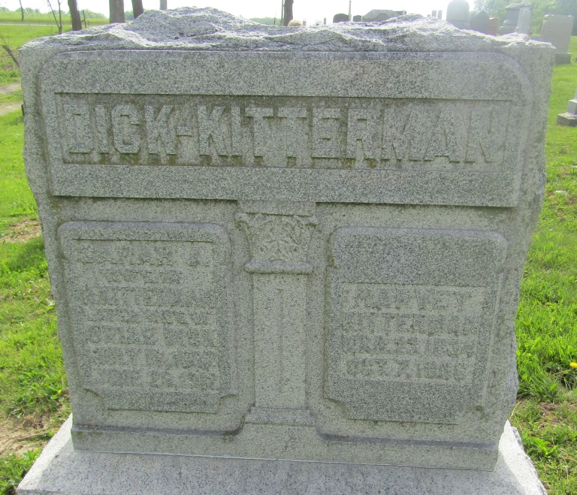

Sarah Jane Dick
in the Indiana, U.S., Death Certificates, 1899-2011
Name: Sarah Jane Dick
[Sarah Jane Wickersham]
Gender: Female
Race: White
Age: 74
Marital status: Widowed
Birth Date: 16 Jul 1837
Birth Place: Indiana
Death Date: 26 Jun 1912
Death Place: Harrison, Blackford, Indiana, USA
Father: William Wickersham
Mother: Idema Anderson
Informant: Grace Kitterman; Montpelier, Indiana
Burial: June 29, 1912; Wells County, Indiana
*****
Sarah Jane was disowned by the Society of Friends on 9 Feb 1856 for having married contrary to discipline. She died at the farm home of her son, Alonzo William Dick. She is buried next to her first husband, Harvey Kitterman. Her second husband, Uriah Dick is buried in the same cemetery in a different section, on a hill overlooking her grave.
Davis, Sheldon, Escalante, "The Wickersham Family in America," Heritage Books, Inc., 2001

