Infant son Dick
January 26, 1872 – January 27, 1872

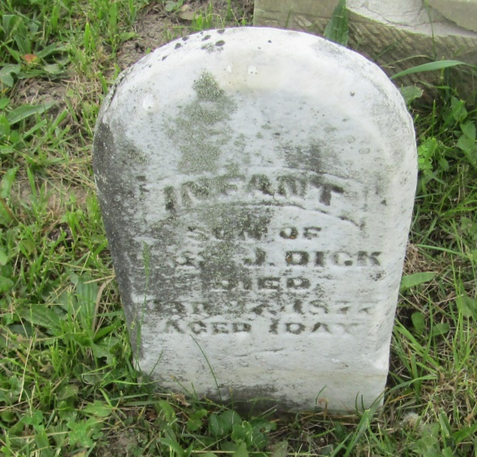

No further information found at this time

