Effie Marie (Banter) Deeter
July 25, 1916 – July 30, 2012

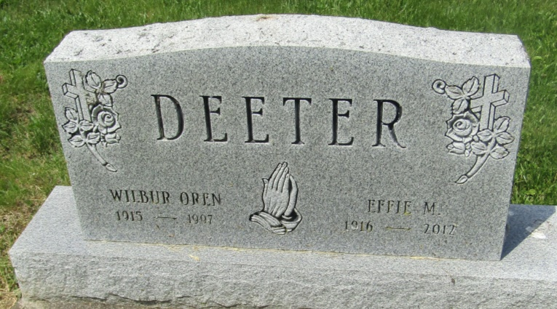

Effie M. Deeter, 96, of Montpelier, IN, passed away at 5:55 AM on Monday, July 30, 2012 at Millers Merry Manor in Dunkirk, IN. She was born on Tuesday, July 25, 1916, in Roll, IN. She married Wilbur "Oren" Deeter on Saturday, September 11, 1937 in Upland, IN.
Mrs. Deeter had worked for Farnsworth in Marion, IN & Upland Canning Factory in Upland, IN. She was a member of the Hartford City Moose Lodge, Montpelier Lions Club and the V.F.W. Auxiliary.
Mrs. Deeter had been at Millers Merry Manor since 2008.
Mrs. Deeter is survived by Several Nieces & Nephews. She was preceded in death by her Father - Newton Banter, Mother - Katie Elizabeth (Speece), Banter, Husband - Wilbur "Oren" Deeter, Brother - Carl Banter, Brother - Kenneth Banter, Sister - Jennie Carl, Half-Brother - Fronz Bennett.
Family and friends may gather to share and remember at Walker & Glancy Funeral Home 109 W Windsor St Montpelier on Thursday, August 02, 2012 from 12:00 PM to 2:00 PM. A service to celebrate Mrs. Deeter's life will be at Walker & Glancy Funeral Home 109 W Windsor St Montpelier at 2:00 PM on Thursday, August 02, 2012 with the Rev. Steve Sutton officiating. Interment will follow in the Asbury Cemetery in Wells County.

Glancy Funeral Homes, Blackford County, Indiana
July 31, 2012
*****
Effie M. Deeter
in the Web: Grant County, Indiana, Marion Public Library Death Index, 1812-2015
Name: Effie M. Deeter
Death Date: 30 Jul 2012
Publication Date: 1 Aug 2012
Publication Place: Grant, Indiana, USA
Publication Title: Marion Chronicle Tribune
Notes: Obits indexed by Indiana Room Staff
Record Type: Obituary

