Thomas Dearduff
September 1, 1831 – January 2, 1898

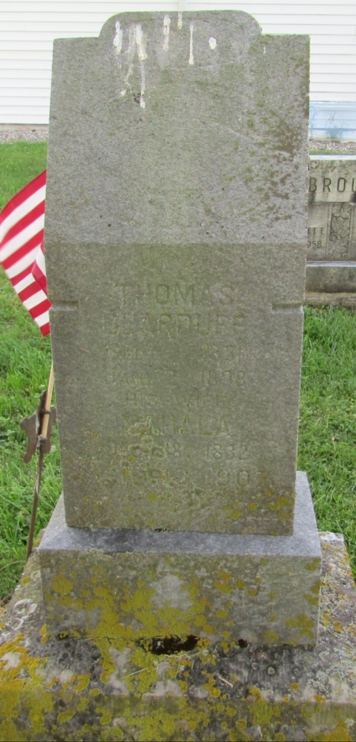

No further information found at this time

