James F. Dearduff
June 1, 1871 – October 26, 1925

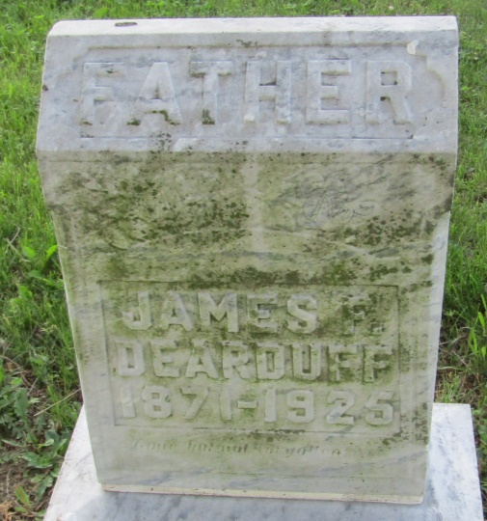

James F Dearduff
in the Indiana, Death Certificates, 1899-2011
Name: James F Dearduff
Gender: Male
Race: White
Age: 54
Marital status: Widowed
Birth Date: 1 Jun 1871
Birth Place: Indian
Death Date: 26 Oct 1925
Death Place: Washington, Grant, Indiana , USA
Father: Thomas Dearduff
Mother: Bertha G Black
Spouse: Mary L
Informant: ?? Dearduff; Marion, Ind.
Burial: Oct. 28, 1925; Asbury Cemetery, Wells Co.

