Isac Wesley Dearduff
January 30, 1880 – July 29, 1901

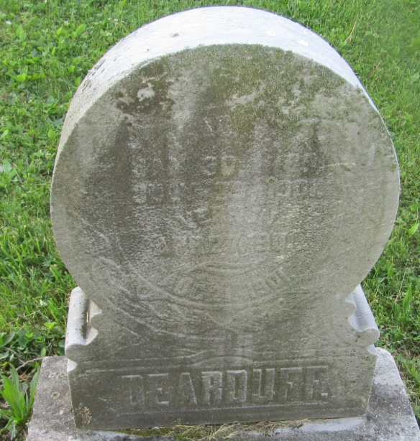

Wesley Dearduff
in the Indiana, Death Certificates, 1899-2011
Name: Wesley Dearduff
Gender: Male
Age: 22
Marital status: Married
Birth Date: abt 1879
Birth Place: Indiana
Death Date: 29 Jul 1901
Death Place: Washington, Blackford, Indiana, USA
Father: Thomas Dearduff
Mother: Mahorey John??
Informant: M. L. Runkle; Roll, Ind.
Burial: July 31, 1901; Asbury Chapel, Wells Co.

