Lloyd “Al” Dawson
June 9, 1926 – September 19, 2013

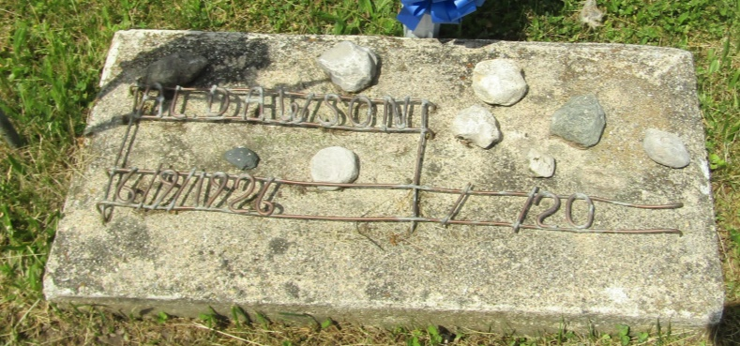

Lloyd "Al" Dawson, 87, of Hartford City, IN, passed away at 5:55 PM on Thursday, September 19, 2013 at Bridgewater Centre for Health & Rehabilitation in Hartford City, IN. He was born on Wednesday, June 09, 1926, in Jackson Twp., Wells County, IN. Al was an owner-operator of Al's Repair Service, where he was a plumber, electrician and a carpenter. He was a life member of the Amvets Post 23 in Hartford City. Al served in the US Army during WWII in Germany. He served as a Private First Class throughout the war and was an active solider during the Battle of Bulge.
He had been a resident of Hartford City since 1965 and was a former resident of Warren. Al loved fishing, carpentry work, and was especially proud of his children. He enjoyed socializing with the people of Hartford City and was a well know resident in the community. Al attended Alexander School, 5 Pts. School, and was a graduate of Jackson Center High School. He was a member of the Jackson Alumni Association.

Glancy Funeral Homes, Blackford County, Indiana
September 20, 2013

