Guy Clark Dawson
April 16, 1907 – August 6, 1974

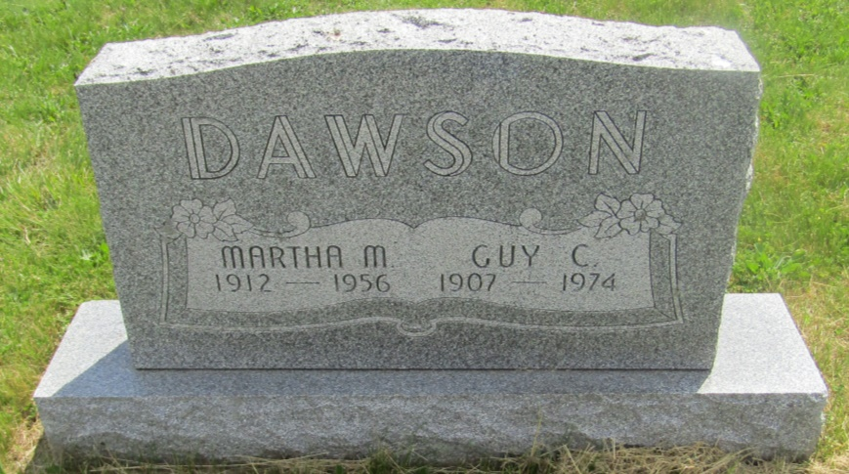

Guy C Dawson
in the Indiana, Death Certificates, 1899-2011
Name: Guy C Dawson
[Guy Clark Dawson ]
Gender: Male
Race: White
Age: 67
Marital status: Widowed
Birth Date: 16 Apr 1907
Birth Place: Indiana
Death Date: 6 Aug 1974
Death Place: Fort Wayne, Allen, Indiana , USA
Father: Edward L Dawson
Mother: Alice Emily Batson
Informant: Irene Byron Hospital records; Ft. Wayne, Ind.
Burial: Aug. 9, 1974; Asbury Cemetery, Montpelier, Ind.

