Ethel F. Dawson
December 16, 1907 – December 17, 1907

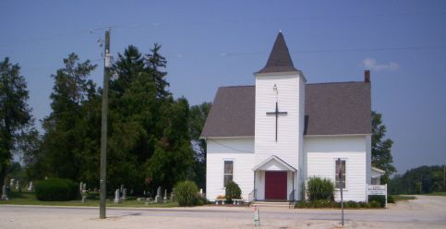
Photo by Barbara Baker Anderson

Ethal F Dawson
in the Indiana, Death Certificates, 1899-2011
Name: Ethel F Dawson
Gender: Female
Race: White
Age: 18 hours
Birth Date: 16 Dec 1907
Death Date: 17 Dec 1907
Death Place: Jackson, Wells, Indiana, USA
Father: Mack Dawson
Mother: Corina M Brown
Burial: Dec. 18, 1907; Asbury Chapel

