Amelia G. Dawson
June 6, 1872 – January 1, 1883

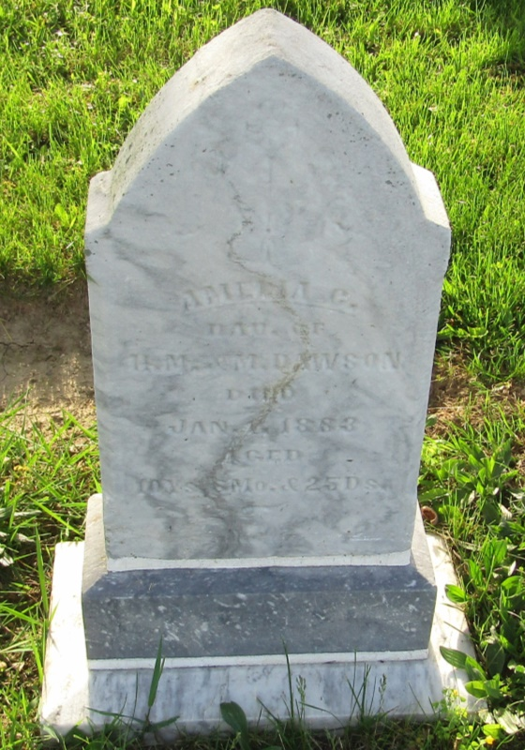

No further information found at this time

