Alice Emily (Batson) Dawson
September 23, 1883 – February 4, 1974

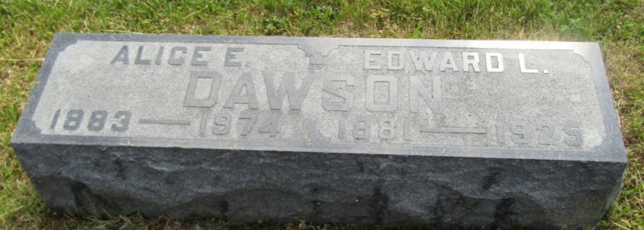

Mrs. Alice Emily Dawson, 90, a resident of Route 1, Poneto, Indiana died Monday in Wells Community Hospital. A daughter of Benjamin and Alice Batson, she was born September 23, 1883 in Wells County. Her marriage was to Edward L. Dawson who died in 1923.
Surviving is a son, Guy, of Pennville, Route 1, two grandchildren and three great grandchildren.
Services will be held Wednesday at the Walker Funeral Home in Montpelier with Rev. Harry Mann officiating; burial in Asbury Cemetery.
Bluffton News-Banner, Wells County, Indiana
February 4, 1974
*****

Indiana, Death Certificates, 1899-2011
Name: Alice Emily Dawson
[Alice Emily Batson]
Gender: Female
Race: White
Age: 90
Marital status: Widowed
Birth Date: 23 Sep 1883
Birth Place: Indiana
Death Date: 4 Feb 1974
Death Place: Bluffton, Wells, Indiana, USA
Father: Benjamin Batson
Mother: Alice Batson
Informant: Guy Dawson; son; Pennville, Ind.
Burial: Feb. 6, 1974; Asbury Cemetery, Montpelier, Ind.

