Russell Dean Crisamore
January 20, 1911 – September 11, 1971

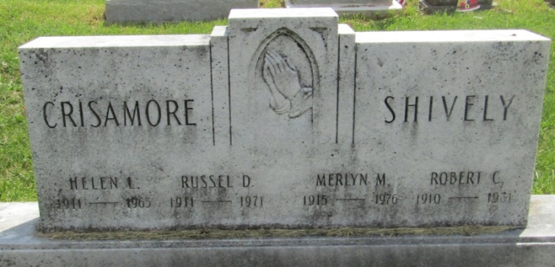

Russell Dean Crisamore, 60, died Saturday at his home in Montpelier. He was a retired farmer and a former employee at Franklin Electric.
The only survivors are a sister, Mrs. Jess Williams of West Palm Beach, Florida and his father-in-law, Willis Flick of Montpelier.
Services were held today at the Walker Funeral Home in Montpelier; burial was in Asbury Cemetery northwest of Montpelier.

Bluffton News-Banner, Wells County, Indiana
September 11, 1971
*****

Indiana, U.S., Death Certificates, 1899-2011
Name: Russell Dean Crisamore
Gender: Male
Race: White
Age: 60
Marital status: Widowed
Birth Date: 20 Jan 1911
Birth Place: Indiana
Death Date: 11 Sep 1971
Death Place: Montpelier, Blackford, Indiana, USA
Father: William Elmer Crisamore
Mother: Rebecca Jane Rowe
Informant: Lester F. Crisamore; uncle; Montpelier, Indiana
Burial: September 14, 1971; Asbury Cemetery; Montpelier, Indiana

