William Jesse Couch
January 23, 1932 – February 10, 2021

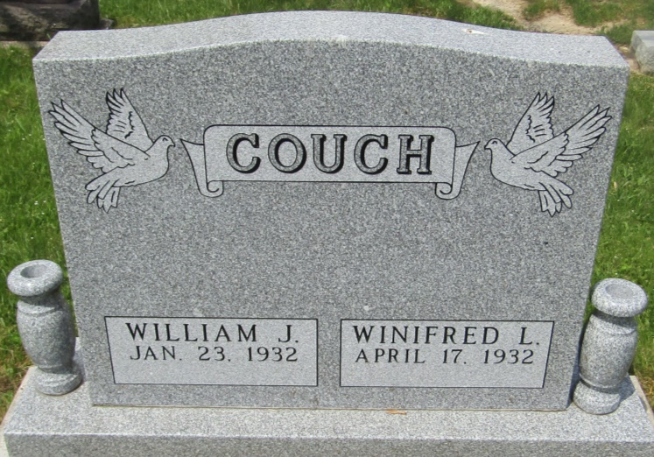

William “Bill” Couch age 89 of Warren, Indiana, formerly of Jackson Twp., Wells County, passed away on February 10, 2021. He was born January 23, 1932, in Wells County, Indiana, to Harry and Ruth (Roberts) Couch. He is preceded in death by his wife of almost 70 years, Winifred “Freddie” (Griffith) Couch, whom he married on September 2, 1951, at Asbury Chapel.
Bill was a 1950 graduate of Jackson High School in Wells County and earned a Bachelor of Arts degree from Huntington College, and a master’s degree and Administrator Certification from Ball State University. Bill taught, coached or was an administrator in several places in Indiana.
He taught History and Government at Roll, and Jackson Township. He was principal at Eaton, principal and superintendent at Liberty-Perry School Corporation, principal at Southern Wells, and superintendent at Blackford and Lawrenceburg schools. He retired as superintendent of Shelbyville schools.
In retirement, he managed the Countrymark Co-op in Shelbyville.
Both Freddie and Bill lived their lives in positive service to their family, society in general and service to our Lord. “We pray that our lives have made this earth a better place and that our service has been an enhancement to all people” ~Bill and Freddie Couch.
He is survived by one brother, Harry J. Couch (Melinda) of Tipp City, Ohio, and 4 children, William (Angela) Couch, Robert (Elizabeth) Couch, Tresa (Steve) Patz and Bryan Couch. He is also survived by grandchildren Travis (Rose) Couch, Bruce Couch, Candice (Brandon) Cox, Brandon Couch, Ross (Holly) Patz, Kyle (Mariah) Couch, Kendra Couch, and Stephanie (Casey) Wildeman. His great-grandchildren are, Quentin, Autumn, Jayden, Amberlynn, Asuna, Callie Jo, Grayson and Leyland.
Bill was preceded in death by his parents, two brothers, Robert and Paul Couch and one sister, Mary Couch. He was also preceded by son, Bruce Allen Couch, grandson Chad Couch and granddaughter Alyssa Couch.
No services will be scheduled at this time. An inturnment will take place at a later date in Asbury Cemetery, Wells County.

Glancy Funeral Homes, Huntington County, Indiana
February 12, 2021

