Lawrence Eugene Claytor
June 13, 1926 – June 19, 1988

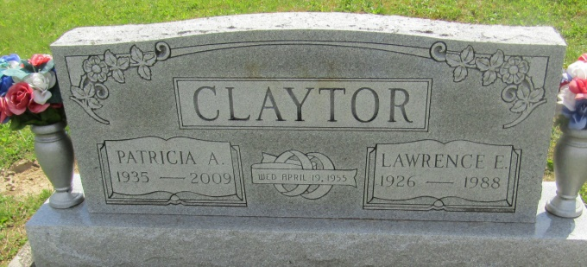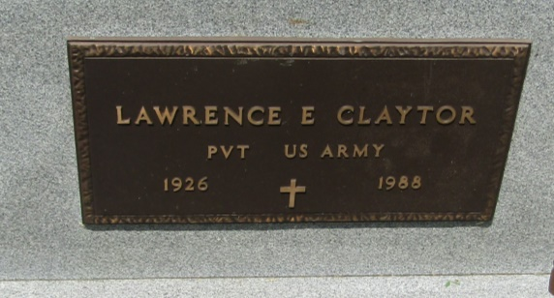

Lawrence Claytor
in the U.S., Department of Veterans Affairs BIRLS Death File, 1850-2010
Name: Lawrence Claytor
Gender: Male
Birth Date: 13 Jun 1926
Death Date: 19 Jun 1988
Cause of Death: Natural
SSN: xxx
Branch 1: A
Enlistment Date 1: 3 Feb 1955
Release Date 1: 1 Feb 1957
*****

Indiana, Death Certificates, 1899-2011

Name: Lawrence E Clayton (sic)
Gender: Male
Race: White
Age: 62
Marital status: Married
Birth Date: 13 Jun 1926
Birth Place: Hartford City Ind
Death Date: 19 Jun 1988
Death Place: Hartford, Blackford, Indiana, USA
Father: Stephen B Clayton
Mother: Celest M Bell
Spouse: Patricia Ford
Informant: Patricia Clayton, Hartford City, Ind.
Burial: June 22, 1988 Asbury Cem.

