Naadene A. (Stafford) Clark
July 29, 1933 – December 24, 2020

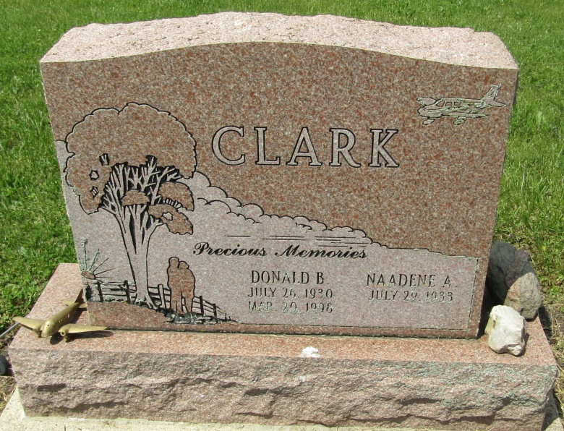

Naadene A. Stafford Clark, 87, of Peru, Indiana, passed away on Christmas Eve at 10:20 PM on Thursday, December 24, 2020 at her home with her loved ones near. Heaven gained a hard-working, loving, caring, very special Mom and Grammy! It never mattered how she felt, she always worried about everyone else and held a genuine deep love for her children and grandchildren.
Naadene was born in The Dalles, Oregon on July 29, 1933. She worked in Marion for many years, where she retired from Foster Forbes.
She married Donald B. Clark on Saturday, December 30, 1950. They celebrated many years together riding Harleys and always doing new and exciting things with their children as they grew up. She enjoyed long talks, watching westerns, reading and listening to music and ventures with her granddaughter Jessica later in life (their bond ran deep.) She missed her husband and sons in her many years, but she never lost sight of what she always had around her. She resided in Washington Township, Blackford County, prior to moving to Peru in 2018.
Survivors include two daughters Janis (Steve) Rister, Kokomo, IN, Naadene Eileen (Nate) Fancher, Hartford City, Indiana, grandchildren - Sara (Laci) Montgomery, Auburn, Indiana, Tiffiny (Matthew) Bunn, Kokomo, Indiana, Lindsee Fancher, Fort Wayne, Indiana, Alesha (Ryan) Reed, Mexico, Indiana, Jessica (Travis) Martinez, Peru, Indiana, Joshua (Brittany) Clark, Dayton, Ohio, Onda Gail Clark, Matthews, and Eric Weaver, Upland, Indiana and many great grands she loved dearly!
She was preceded in death by her parents Joe Stafford & Billie Halibe (Davis) Bartlemay, husband - Donald B. Clark, sons – Joe, George, and Donald "Alan" Clark.
Family and friends may gather to share and remember at Asbury Chapel United Methodist Church 8013 W. 1100 S. Montpelier on Wednesday, December 30, 2020 from 1:00 PM to 3:00 PM. A service to celebrate her life will follow at 3:00 PM on Wednesday, December 30, 2020 with the Rev. Phillip Freel officiating. Interment will follow in the Asbury Cemetery in Wells County.

Bluffton News-Banner, Wells County, Indiana
December 25, 2020

