Phillip B. Chew
February 16, 1936 – March 18, 1990

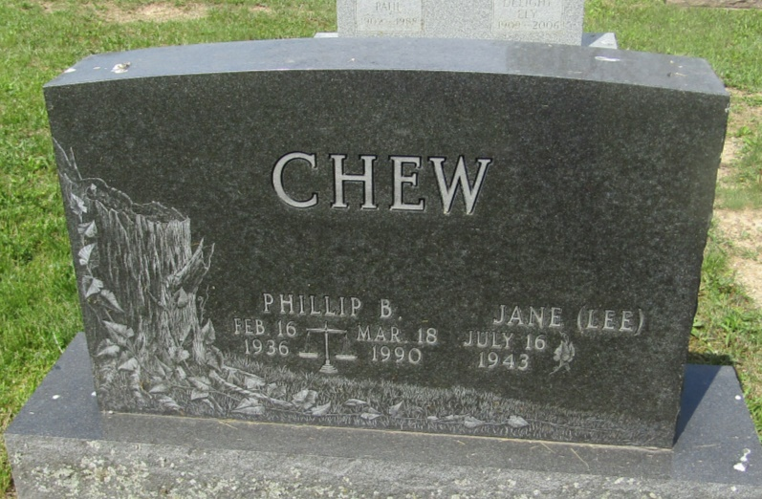

Phillip B Chew
in the Indiana, U.S., Death Certificates, 1899-2011
Name: Phillip B Chew
Gender: Male
Race: White
Age: 54
Marital status: Married
Birth Date: 16 Feb 1936
Birth Place: Berne, In
Death Date: 18 Mar 1990
Death Place: Plainfield, Hendricks, Indiana, USA
Father: Charrel M Chew
Mother: Adeline R Brown
Spouse: Jane Lee
Informant: Jane L. Chew; wife; Plainfield, Indiana
Cremation: March 21, 1990; American Midwest Crematory; Indianapolis, Indiana

