George Frederick Carnes
December 11, 1915 – September 19, 2014

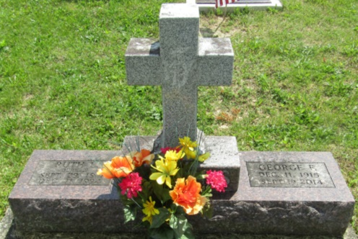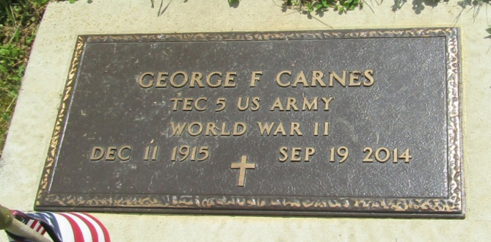

George Frederick Carnes, a truly loving and caring husband, father, grandfather, great grandfather, great-great-grandfather, and good friend, died in Muncie, Indiana, on September 19, 2014, age 98.
He was born on a farm in Chester Township, Wells County, Indiana on December 11, 1915, the son of Ray F. and Grace M. Carnes. In the fall of 1921 he started school riding horse-back to a schoolhouse in Keystone, Indiana that had no inside toilets, no running water, and no electricity. He grew up working in a number of the family businesses--farming, general store, sale barn, raising and trading livestock. As a boy he drove livestock trucks to Muncie, Fort Wayne, Indianapolis, Cincinnati, Chicago, and other cities to pick up and deliver horses, cattle, hogs and sheep.
On July 6, 1924, Mr. Carnes was baptized in Brandywine Creek near Greenfield, Indiana, by his paternal grandfather the Reverend George W. Carnes. In April 1933, he graduated from Chester Center High School in Wells County, Indiana, where he played basketball and was captain of the team. On March 22, 1936, he married Ruth Lucille Burklo at the home of Rev. George W. Carnes who performed the ceremony. There were few jobs to be had during the hard times of the depression. George took whatever work he could find including unloading coal cars, selling merchandise from a Huckster wagon, and delivering gasoline and fuel oil, and factory work of many kinds when it was available.
On May 31, 1937, George and Ruth had their first son Frederick E. Carnes. After taking Indiana State Police training George became a guard at the Indiana State Farm at Putnamville, Indiana. A second son Robert B. Carnes was born on May 8, 1942. In February 1945, while serving as assistant chief clerk at the Indiana State Farm, George was drafted into the U.S. Army and trained as an infantryman. His unit was preparing for the invasion of Japan; however, the Atomic Bomb ended WW-II before they shipped overseas. George was honorably discharged in January 1946. He found employment at the Kuhner Packing Company, later known as the Marhoefer Packing Company and moved his family to Muncie, Indiana.
In 1978 George retired from Marhoefer's after 32 years of faithful service in their Livestock Office. For the next 16 years he was a loving husband and caregiver to his lifelong sweetheart and wife Ruth. They enjoyed traveling to visit friends and family, fishing at Prairie Creek Reservoir, and George liked to read and garden while Ruth knitted. Ruth died on December 11, 1994, on George's 79'h birthday.
George stayed active and was frequently seen walking from his home on University Ave. in Muncie to the Ball State Student Union to buy his morning newspaper or walking to First Merchant's Bank in the Village. Even into his late eighties he could at times be seen on his bicycle or riding on the back of a motorcycle with his good friend Cliff Ingalsbe. George was always a welcome guest by his and Ruth's relatives, whom he visited frequently. He liked to drive and made many trips to Colorado, Florida, and other locations to be with his sons, his grandchildren, and his great grandchildren, especially on holidays.
The Carnes family is very grateful to Sheila Jett for the friendship, assistance, and care she provided George over many years.
George was a 50-year member of Cloverdale Masonic Lodge 132 F&AM, member of Madison Street Methodist Church, United Commercial Travelers and Peoples Sympathy Club 105.
George F. Carnes was predeceased by his older brother Arthur, his younger brother Lawrence, his younger sister Faith Goodspeed, and two sisters Jesse and Hope, who died in infancy. He is survived by sons Fred and his wife Shirley, and Robert F. and his wife Pat. George had four grandchildren: Todi S. Carnes and Shay T. Carnes, children of Fred and Shirley Carnes; and Robert F. Carnes and Angela Marshall, children of Robert B. and Pat Carnes. George is also survived by nine great-grandchildren, three step great-grandchildren, and one great-great-grandchild.
Visitation with family will be from 6 to 8 PM, Monday September 22, 2014, at the Walker & Glancy Funeral Home 109 West Windsor St. Montpelier, Indiana. A Masonic service will be held at 7 PM. The funeral service will start at 10 AM, Tuesday, September 23, 2014, also at the Walker & Glancy Funeral Home in Montpelier. George will be laid to rest beside Ruth, his wife and sweetheart, in the Asbury Chapel Cemetery, on Highway 3 in Wells County, Indiana. Following the funeral a reception and lunch will be held at Richard's Restaurant on Highway 3 south of Hartford City, Indiana.

Glancy Funeral Homes, Blackford County, Indiana
September 20, 2014

