Rosanna Byall
June 21, 1851 – February 28, 1867

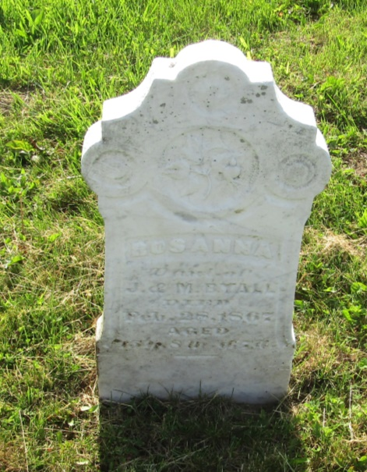

No further information found at this time

