Rachel A. Byall
December 26, 1853 – February 22, 1867

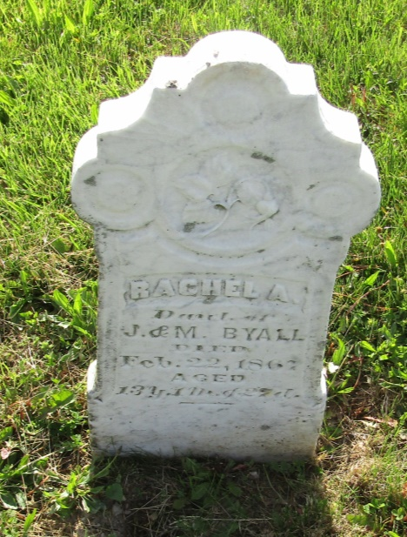

No further information found at this time

