John Byall
June 23, 1817 – September 16, 1883

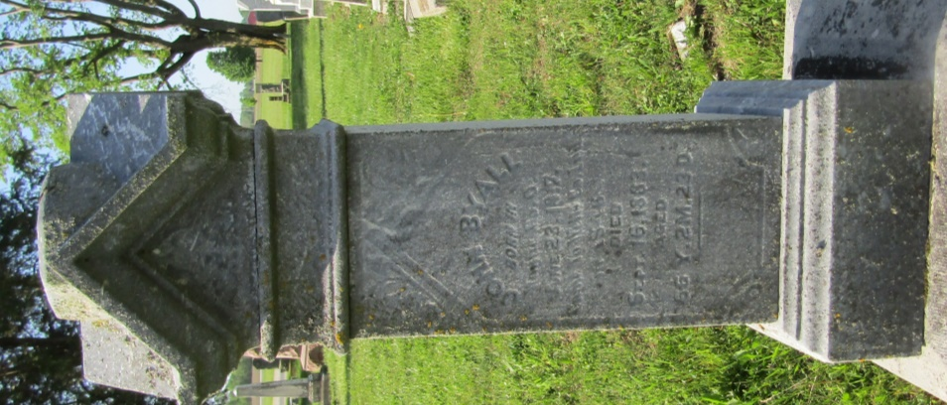

No further information found at this time

