Addie Blanche (Storms) Byall
November 14, 1883 – May 31, 1968

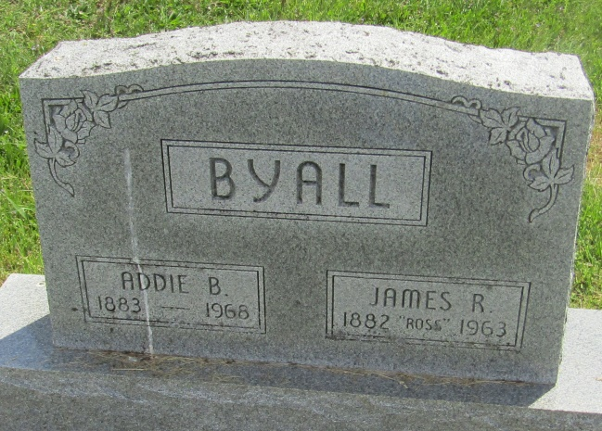

Addie Blanche Byall
in the Indiana, U.S., Death Certificates, 1899-2011
Name: Addie Blanche Byall
[Addie Blanche Starns]
Gender: Female
Race: White
Age: 84
Marital status: Widowed
Birth Date: 14 Nov 1883
Birth Place: Indiana
Death Date: 31 May 1968
Death Place: Hartford City, Blackford, Indiana, USA
Father: Elmer C Starms/Starns
Mother: Lovina Glancy
Informant: Bruce Byall; son; Gas City, Indiana
Burial: June 3, 1968; Asbury Cemetery; Wells County, Indiana

