Wanda Ellen (Huston) Bush
May 19, 1922 – August 2, 2002

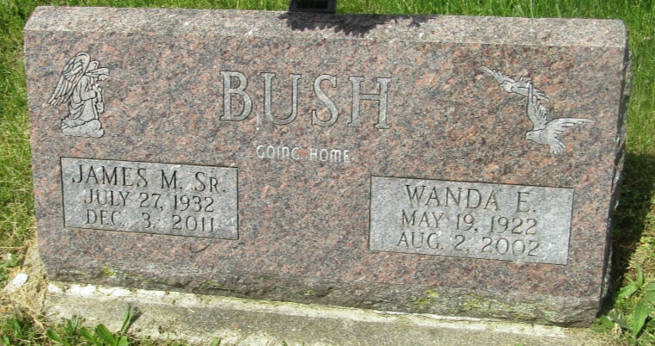

Indiana, U.S., Birth Certificates, 1907-1940
Name: Wanda Ellen Huston
Gender: Female
Birth Date: 19 May 1922
Birth Place: Green, Randolph, Indiana, USA
Registration Year: 1922
Father: Chas A Huston
Mother: Leota May Beedy
Certificate Number: 25606
Roll Number: 011
Agency: Indiana State Board of Health
Volume Range: 51 - 55
*****

U.S., Social Security Death Index, 1935-2014
Name: Wanda E. Bush
Social Security Number: xxx
Birth Date: 19 May 1922
Issue Year: Before 1951
Issue State: Indiana
Last Residence: 71960, Norman, Montgomery, Arkansas, USA
Death Date: 2 Aug 2002
*****

Web: Grant County, Indiana, U.S., Marion Public Library Death Index, 1812-2015
Name: Wanda Ellen Bush
[Wanda Ellen Shaffer]
[Wanda Ellen Huston]
Birth Date: 19 May 1922
Death Date: 2 Aug 2002
Publication Date: 6 Aug 2002
Publication Place: Grant, Indiana, USA
Publication Title: Marion Chronicle Tribune
Notes: Obits indexed by Indiana Room Staff
Record Type: Obituary
URL: http://www.marion.lib.in.us/request-genealogy-records-2/

