James M. Bush, Sr.
July 27, 1932 – December 3, 2011

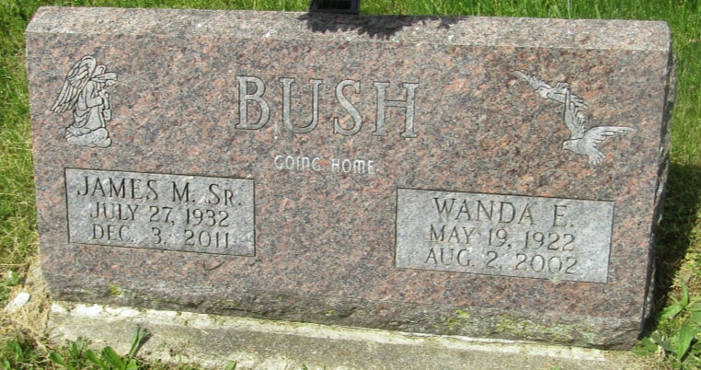

James M Bush
in the U.S., Social Security Death Index, 1935-2014
Name: James M Bush
Social Security Number: xxx
Birth Date: 27 Jul 1933 [sic]
Issue Year: Before 1951
Issue State: Indiana
Death Date: 3 Dec 2011
*****

U.S., Obituary Collection, 1930-Current
Name: James M. Bush
Death Age: 78
Birth Date: 27 Jul 1933 [sic]
Residence Place: Norman, Arkansas
Death Date: 3 Dec 2011
Death Place: Norman, Arkansas

