William Burchard
November 16, 1881 – February 26, 1955

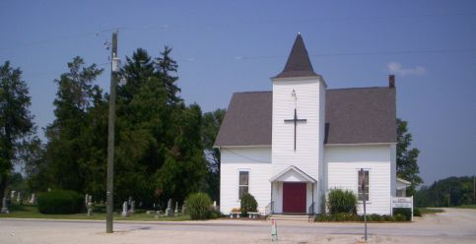
Photo by Barbara Baker Anderson

William Burchard
in the Michigan, U.S., Deaths and Burials Index, 1867-1995
Name: William Burchard
Birth Date: 16 Nov 1881
Birth Place: Blackford Co., Ind
Death Date: 26 Feb 1955
Death Place: Centerville, St.Joseph Co., Mich.
Death Age: 73
Race: White
Marital Status: Married
Gender: Male
Father Name: John Burchard
Mother Name: Eve McIntrie
Spouse Name: Estella Burchard
FHL Film Number: 1940445

