Eva (McIntire) Burchard
March 17, 1830 – January 20, 1920

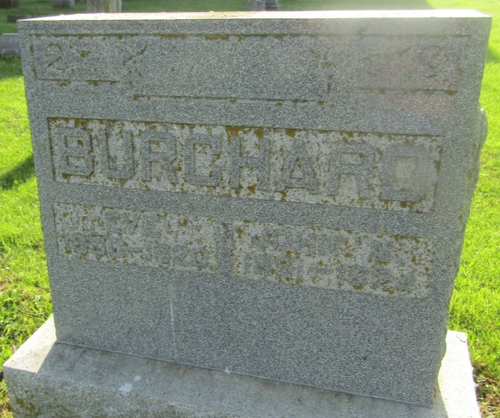

Eva Burchard
in the Indiana, U.S., Death Certificates, 1899-2011
Name: Eva Burchard
[Eva McIntire]
Maiden Name: Bunchard
Gender: Female
Race: White
Age: 90
Marital status: Married
Birth Date: 17 Mar 1830
Birth Place: Indiana
Death Date: 20 Jan 1920
Death Place: Hartford Ciry, Blackford, Indiana, USA
Father: Nunn McIntire
Mother: Mary A. Speelman
Spouse: John M. Burchard
Informant: John M. Burchard; Hartford City, Indiana
Burial: January 22, 1920; Asbury Chapel

