Mary Emily Brotherton
August 14, 1917 – November 7, 1917

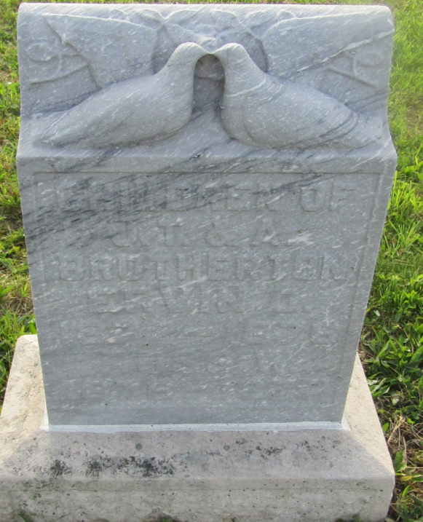

Mary Emily Broltherton
in the Indiana, U.S., Death Certificates, 1899-2011
Name: Mary Emily Brotherton
Gender: Female
Race: White
Age: 2/12
Marital status: Widowed
Birth Date: 14 Aug 1917
Birth Place: Blackford Co, Ind
Death Date: 7 Nov 1917; influenza
Death Place: Washington, Blackford, Indiana, USA
Father: James C. Brotherton
Mother: Ada E. Woodard
Informant: James C. Brotherton; Hartford City, Indiana
Burial: November 8, 1917; Asbury Chapel; Roll, Indiana

