Johanah (Rouse) Booher
April 20, 1833 – September 29, 1900

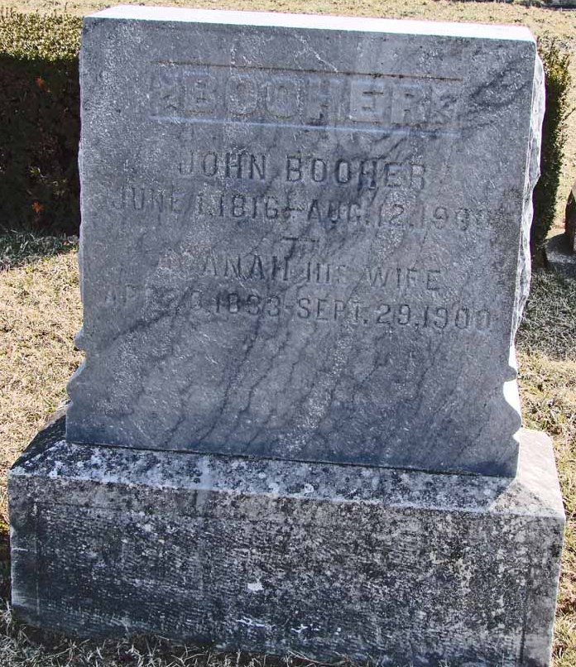
Photo by Ron Oswalt

Indiana, U.S., Death Certificates, 1899-2011
Name: Joannah Booher
Gender: Female
Race: White
Marital status: Widow
Birth: April 26, 1833
Birth Place: Jefferson Co Ohio
Death Date: 29 Sep 1900
Death Place: Jackson, Wells, Indiana, USA
Parents: Not listed
Informant: William Booher
Burial: Asbury Chapel; Wells County

