Allen L. Bole
November 21, 1947 – November 25, 2019

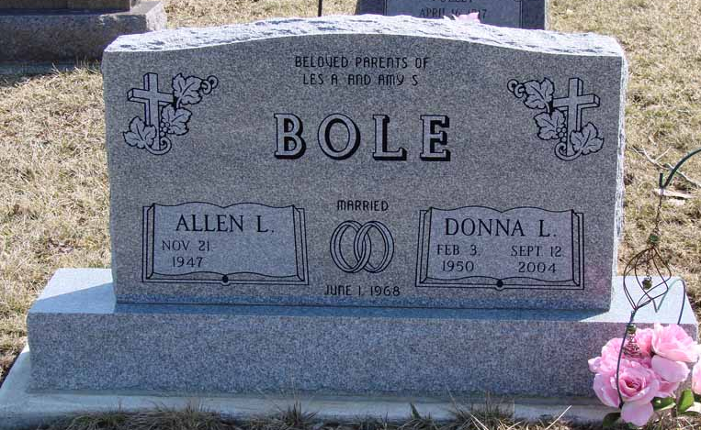
Photo by Ron Oswalt

Hartford City - Allen L. Bole, 72, passed away at 2:40 p.m. Monday, November 25, 2019 at his residence.
He was born in Hartford City on November 21, 1947 to Raymond Bole and Opal L. (Rinker) Bole. His parents preceded him in death.
Allen graduated in 1965 from Hartford City High School and from Detroit Auto Mechanic School in 1966. He earned his Machine Apprenticeship from 3-M in 1977.
He married Donna L. (McIlwain) on June 1, 1968 at Roll United Methodist Church. She precedes him in death on September 12, 2004
Allen started his career at Turing Motors as a Mechanic in Hartford City in 1965, he left to go to 3-M Company in Hartford City until he went to CPC (GM) in Marion until his retirement in 2002. He was a member of UAW in Muncie and Pleasant Grove United Methodist Church. He also farmed in Blackford County. Allen enjoyed gardening.
He will be sadly missed by his children, Leslie "Les" A. (wife, Stacy) Bole of Hartford City and Amy S. (husband, Matthew) Lathem of Hartford City; grandchildren, Kelsie Bole (companion, Colbert Adams), Allyson Reece, Taylre Lathem, Jonathan Bole, Gage Lathem and Cassidy Bole; great grandchildren, Jase Bole and Grayce Adams; sister, Thera Kay (husband, Ron) Cochran of Hartford City; several nieces and nephews.
He is also preceded in death by his brother, Raymond Bole and his infant granddaughter, Donalee Jo Lathem.
Funeral service will be at 11 a.m. Monday, December 2, 2019 at Keplinger Funeral Home with Rev. Jon Kellogg officiating. Burial will follow at Asbury Cemetery. Visitation will be from 3 to 5 and 6 to 8 Sunday, December 1, 2019 and from 10 to 11 a.m. Monday, December 2, 2019 at Keplinger Funeral Home.
Memorials may be made to Blackford County Community Foundation-Cancer Services, P.O. Box 327, Hartford City, IN 47348.
Online condolences may be sent to the family at www.keplingerfuneralhome.com
Published in The Star Press (Delaware County, Indiana)
Nov. 26 to Nov. 29, 2019

