Flora Eveline (Phillips) Berrier
March 21, 1886 – November 20, 1914

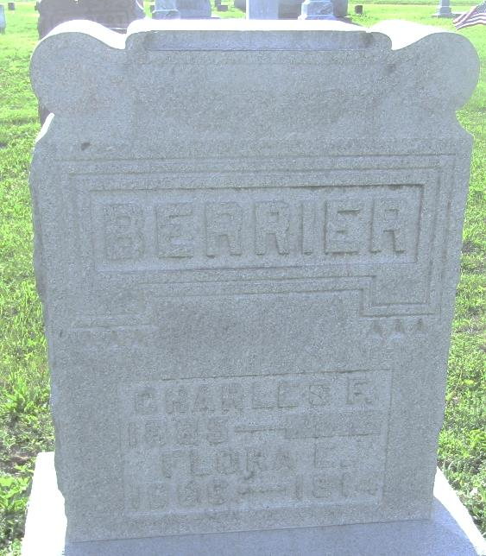

Collection: Ohio Deaths 1908-1953
Name: Flora Eveline Berrier
Death date: 20 Nov 1914
Death place: Dorset Twp, Ashtabula Co., Ohio
Birth date: 21 Mar 1886
Birthplace: Ind.
Age at death: 28 years 7 months 29 days
Gender: Female
Marital status: Married
Race or color: Caucasian
Occupation: Housewife
Burial date: 24 Nov 1914
Burial place: Montpelier, Ind.
Father's name: Fred Phillips
Father's birthplace: Ind.
Mother's name: Minerva Lake
Mother's birthplace: Ind.
GSU film number: 1983284; Digital GS number: 4021357
Image number: 1000; Reference number: fn 58656

