Brent Allen Bennett
February 17, 1989 – November 17, 2012

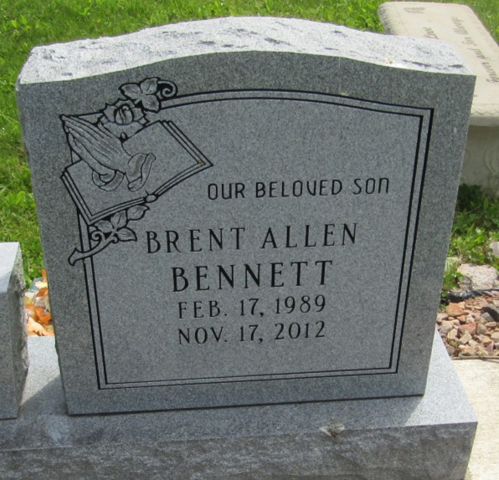

Brent Allen Bennett, 23, of Bluffton, IN, and a former resident of Warren, IN, died unexpectedly on Saturday, Nov. 17, 2012, at 4:09 a.m. at Lutheran Hospital, Fort Wayne.
Mr. Bennett was a 2007 graduate of Bluffton High School. He attended Ivy Tech College, Fort Wayne, and was employed as a production worker.
He was born Feb. 17, 1989, in Bluffton. He is survived by his father, Benjamin G. Bennett, of Warren, and his mother, Deborah Gearheart Crump, of Poneto.
Additional survivors include two sisters, Jorden Bennett, of Warren, and Kendra Crump, of Bluffton; two brothers, Kory Crump, of Poneto, and Damon McCune, of Markle; paternal grandparents, Ted and Becky Pond Foreman, of Bluffton; and maternal grandparents, John and Carolyn Gearheart, of Warren.
Calling is Tuesday, Nov. 20, 2012, from 2 p.m. to 8 p.m. at Glancy-H. Brown & Son Funeral Home, 203 N. Matilda St., Warren. A service will be held at the funeral home on Wednesday, Nov. 21, 2012, at 1 p.m., with Rev. Phillip Freel officiating. Interment will be at Woodlawn Cemetery, Warren.

Huntington Tab, Huntington County, Indiana
November 18, 2012

