Joyce Ann (Pulley) Bantz
January 12, 1941 – January 22, 2001

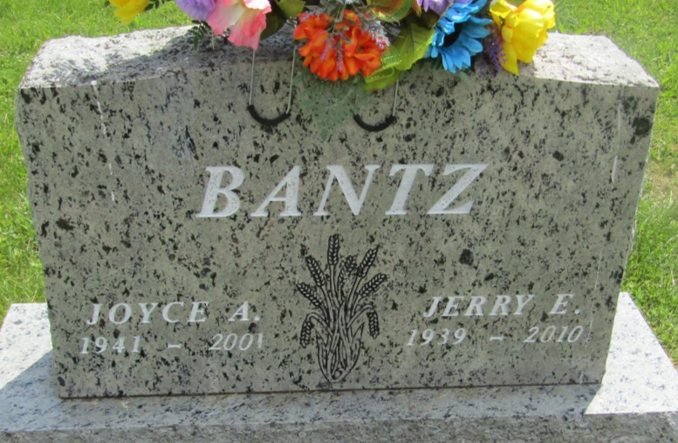
Joyce Anne Bantz, 60, of Hartford City, died at 4:10 a.m. Monday at Lakeland Rehab & Health Center in Milford. She was retired from Overhead Door Co. in Hartford City, where she was employed as a accounts clerk from 1958 to 2000.
She was member of Trinity United Methodist Church. Mrs. Bantz had resided in Wells County in her early years and was a graduate of Chester Center High School. She was born at Hartford City to Dale and Madge J. Berrier Pulley. Her mother died in 1978 and her father survives and resides at Montpelier. Her marriage at Montpelier on June 17, 1961 was to Jerry Edwin Bantz, who survives also.
Other survivors are a daughter, Mrs. David (Julia A.) Staker of Warsaw; a son, Jeffry of West Milton, Ohio; two sisters, Janet Kraner of Montpelier and Mrs. Mack (Judy) Buckland of Warren; a brother, James D. Pulley of Decatur; six grandchildren; and several nieces and nephews.
Services will be at 11 a.m. Saturday at Keplinger Funeral Home in Hartford City with Rev. Merlyn Cox officiating. Burial will be in Asbury Cemetery in Wells County. Visitation hours will be Friday from 4 to 7 and Saturday from 9 a.m. until time for services at the funeral Home.
Memorials to Asbury Chapel Cemetery.
Keplinger Funeral Home, Blackford County, Indiana
January 23, 2001

