Sylvia E. Banter
September 25, 1888 - August 6, 1889

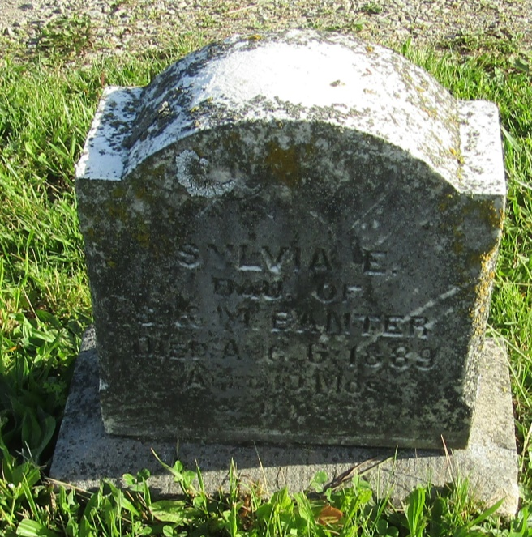

No further information found at this time

