Kenneth Maxwell Banter
September 13, 1918 – February 17, 1940

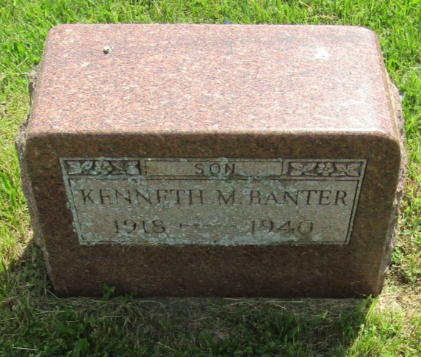
Kenneth Maxwell Banter
in the Indiana, Death Certificates, 1899-2011
Name: Kenneth Maxwell Banter
Gender: Male
Race: White
Age: 21
Marital status: Single
Birth Date: 13 Sep 1918
Birth Place: Montpelier Ind
Death Date: 17 Feb 1940; auto accident
Death Place: Hartford, Blackford, Indiana, USA
Father: Newton Banter
Mother: Katie Elizabeth Speece
Informant: Mrs. Katie Banter; Roll, Ind.
Burial: Feb. 20, 1940; Asbury Chapel Cem., Wells Co., Ind.

