James Richard Banter
March 24, 1940 – August 14, 2019

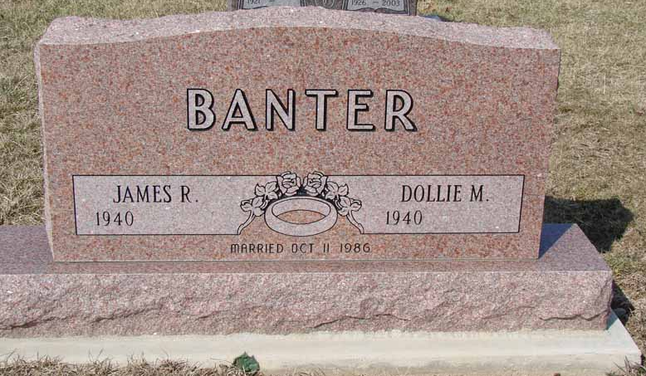
Photo by Ron Oswalt
CONVERSE – James “Jim” Richard Banter, 79, passed away at 5:46 p.m. Wednesday, August 14, 2019 at University Nursing Center in Upland.
He was born on March 24, 1940 to Raymond R. Banter and Lucile (Ledbetter) Donaldson. Both his parents preceded him in death.
Jim married Liana Marie Banter in Maui, Hawaii on April 17, 2015.
He retired from 3M Company in 1997 after 34 years of service, where he was an Engineer. He was an avid bowler and golfer and enjoyed teaching his grandchildren how to do both.
He will be sadly missed by his wife, Liana Banter of Muncie; children, Robert J. “Bob” (wife, Teresa) Banter of Hartford City, Tina (husband, Stephan) Nash of Princeton, Indiana, Charlene (husband, Steven) Maddox of Hartford City and Keith (wife, Karen) Harvill of Hardinsburg, IN; 12 grandchildren and 10 great-grandchildren; siblings, Eugene (wife, Isola) Banter of Hartford City, Victor (wife, Marjorie) Banter of Kentucky and Sandra Harless of Beecher Illinois; sister-in-law, Sara Banter of Highland, Indiana; former wife, Barbara Hardwick of Hartford City; several nieces and nephews.
He is also preceded in death by his wife, Dollie Marie Banter and siblings, Luella May, Lois Henderson and Donald Banter.
Visitation will be from 4 to 7 p.m. Monday, August 19, 2019 at Keplinger Funeral Home, 509 N. High St., Hartford City. Jim will be cremated and a private graveside service will be at Asbury Cemetery at later date.
Memorials may be made to Blackford County Community Foundation-Cancer Service, P.O. Box 327, Hartford City, Indiana 47348.

Keplinger Funeral Home, Blackford County, Indiana
August 15, 2019

